

KG ERP USER MANUAL

**Prepared by: IT Department, Krishibid Group**

Content

Introduction 2

Description of the System 2

1. Dashboard 3

**1.1 ERP Login Page** 3

**1.2 ERP Home Page** 4

2. Setting (Feed) 5

**2.1 Product Category** 5

**2.2 Product Sub Category** 6

**2.3 Product** 7

**2.4 Product Sale Price** 8

**2.5 RM Category** 9

**2.6 RM Sub Category** 10

**2.7 Raw Material** 11

**2.8 Feed Formula** 12

**2.9 District** 13

**2.10 Upazila** 14

**2.11 Assign Area** 15

**2.12 Customers** 15

**2.13 Suppliers** 16

# Introduction

The Krishibid Group has initiated development of Enterprise Resource Planning (ERP) with the essence of establishing an effective database, to address and strengthen existing information system through coordinating and networking of existing human resource data collection systems. Krishibid consulted a team of experts, department of IT of Krishibid Group to take the responsibility of developing, implementing and maintaining ERP system in this organization. **As for any big system development the process is not an overnight thing.** HRMS is evolving, though with a remarkable speed, the inputs of stakeholders are all time required. This manual outlines the systematic procedures for accessing and using various parts of the system.

In case you do not get the assistance, you expected from the manual please consult your system administrator or any person authorized to work as the member of the helpdesk team at your organization.

# Description of the System

The following part is intended to give user an insight on how to use the system and access different features and system components.

# 1. Dashboard

## **1.1 ERP Login Page**

Open the browser and type the following address: http:// [http://192.168.0.7:90](http://192.168.0.7:90/) then a page similar to the one shown in the image below will be displayed whereby a user will be required to type in their correct **username** and **password**. This system works best with Google Chrome, Mozilla Firefox, Microsoft Edge or Opera browsers. From here on, the use of the word “browser” will refer to above mentioned web browsers only.

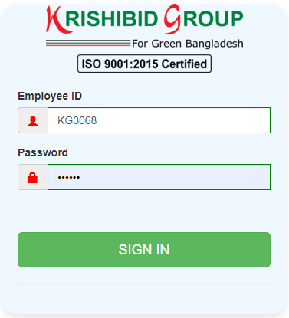

**Figure: 01 ERP Login**

**Logging on ERP System:**

* **Step-1:** Provide Valid **Username and Password. For Username Always Provide your Employee ID. (Example: EmployeeId: KGXXXX, Password: KGXXXX) with UPPERCASE.**
* **Step-2:** Click on **‘Sign In’** button for go to Home page of ERP.

## **1.2 ERP Home Page**

On successful login, a user is directed to the Home Page which consists of the main menu on the left side named dashboard. At the top most part of the system you will have on your left a home icon to denote the home page, a help button- which contains this help manual and the Employee Id of the user currently accessing the system.

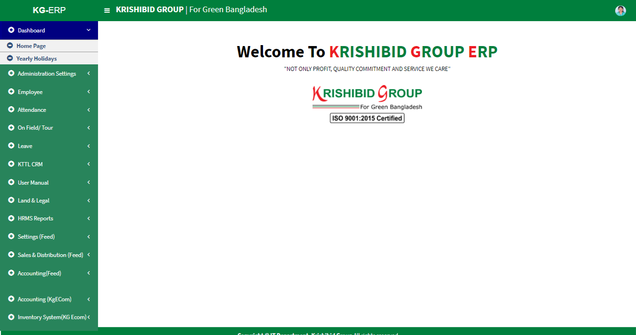The following figure (Fig-02) shows menu bar and home page.

**Figure: 02 ERP Home Page**

* **Step-01:** Click on the Dashboard section under main navigation panel of KG ERP.

# 2. Setting (Feed)

## **2.1 Product Category**

**Figure: 03 Product Category**

The following figure (Fig-03) shows options for Product Category.

* 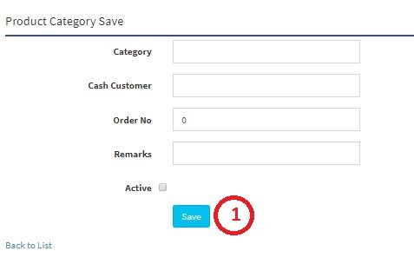**Step-01:** Click on the **Product Category** section under **Settings (Feed) Menu** option. The following figure (Fig-03) shows the **Product Category of Feed** page.

**Figure: 04 Product Category Entry Page**

* **Step-02:** Enter any **“Date” or “Category” or “Purpose”** in the search section and click “Enter” button to search any product.

## **2.2 Product Sub Category**

**Figure: 05 Product Sub Category**

The following figure (Fig-03) shows options for Product Sub Category.

* **Step-01:** Click on the **Product Sub Category** section under **Settings (Feed) Menu** option. The following figure (Fig-03) shows the **Product Sub Category of Feed** page.
* 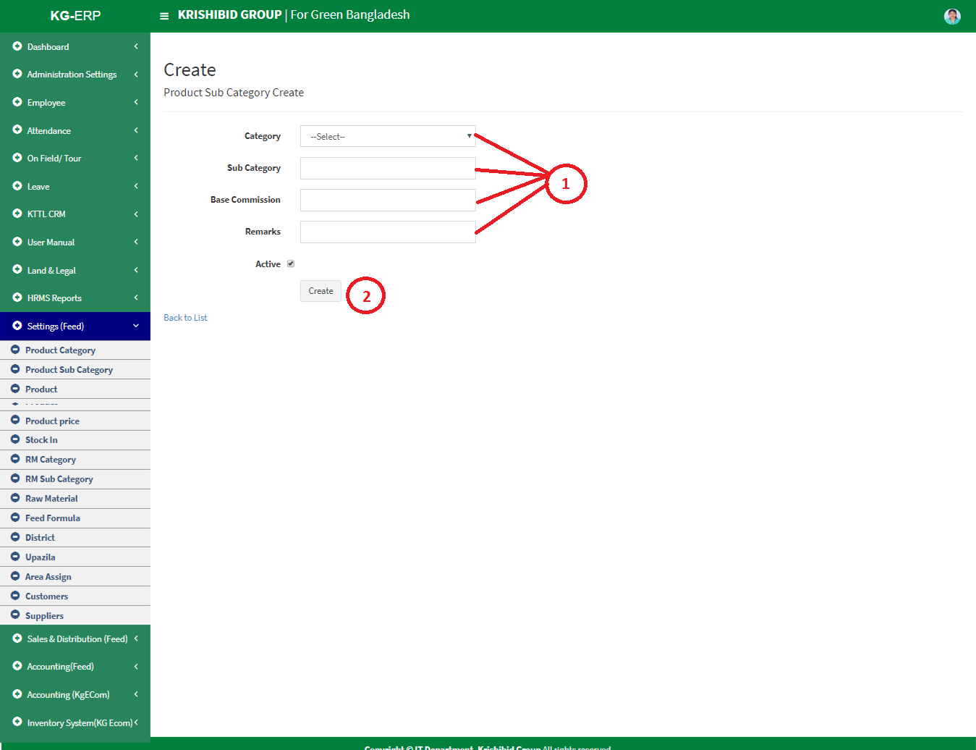**Step-02:** Enter any **“Category” or “Sub Category” or “Purpose”** in the search section and click “Enter” button to search any product.
* **Figure: 6 Create Product Sub Category**
* **Step-01:** Enter any **“Category”, “Sub Category”, “Base Commission”, Check Active button** in the new sub category entry page and click “Create” button to save any new Sub category under the Category.

## **2.3 Product**

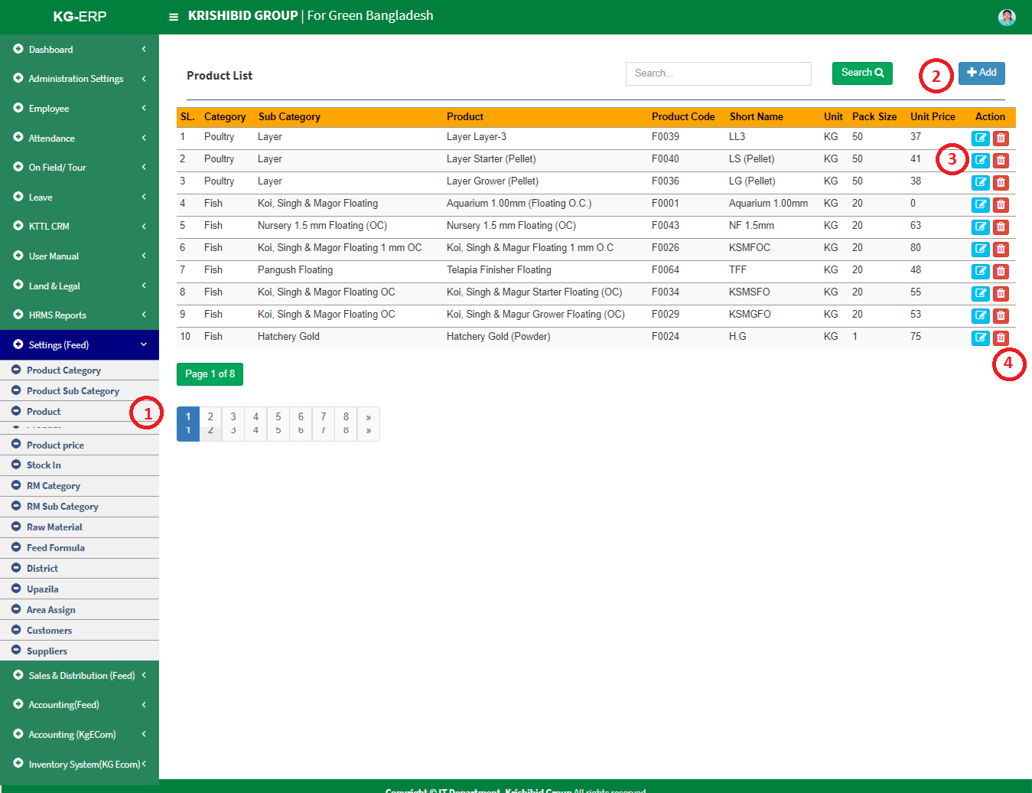

**Figure: 7 Product**

The following figure (Fig-03) shows options for Product.

* **Step-01:** Click on the **Product** section under **Settings (Feed) Menu** option. The following figure (Fig-03) shows the **Product of Feed** page.
* 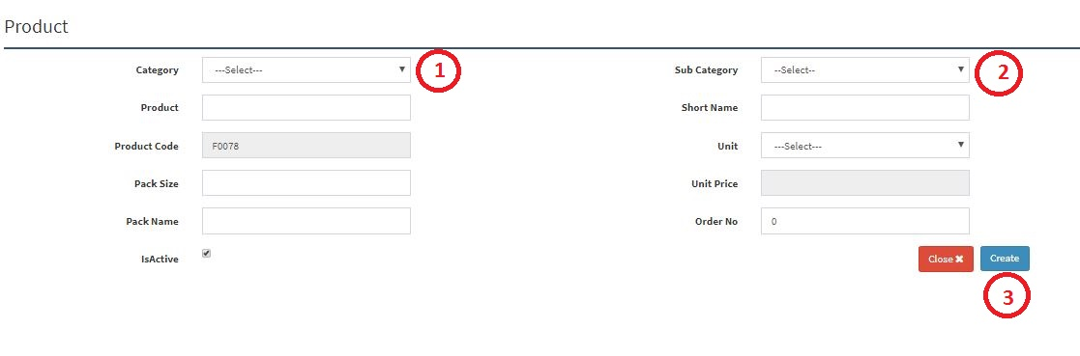**Step-02:** Enter any **“Category” or “Sub Category” or “Product”** in the search section and click “Enter” button to search any product.
* **Figure: 8 Product Entry Page**
* **Step-02:** Enter **‘Category’, ‘Sub Category’, ‘Product’, ‘Short Name’, ‘Unit’, ‘Pack Size’, ‘Pack Name’, ‘Order No’** and click “Create” button to save any new product.

## **2.4 Product Sale Price**

**Figure: 9 Product Sale Price**

The following figure (Fig-03) shows options for Product Sale Price.

* **Step-01:** Click on the **Product Sale Price** section under **Settings (Feed) Menu** option. The following figure (Fig-03) shows the **Product of Feed** page.
* 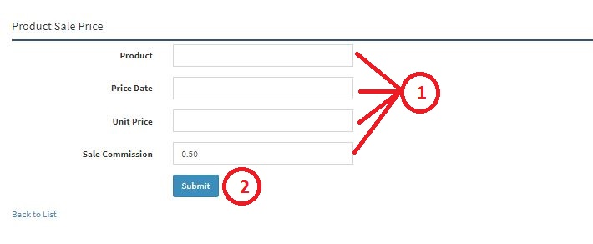**Step-02:** Enter any **“Date” or “Product”** in the search section and click “Enter” button to search any products Sale price.
* **Figure: 10 Product Sale Price Entry Page**
* **Step-02:** Enter **‘Product’, ‘Price Date’, ‘Unit Price’, ‘Sale Commission’** and click “Submit” button to save any new Product Sale Price.

## **2.5 RM Category**

**Figure: 11 RM Category**

The following figure (Fig-03) shows options for RM Category.

* **Step-01:** Click on the **RM Category** section under **Settings (Feed) Menu** option. The following figure (Fig-03) shows the **Product of Feed** page.
* 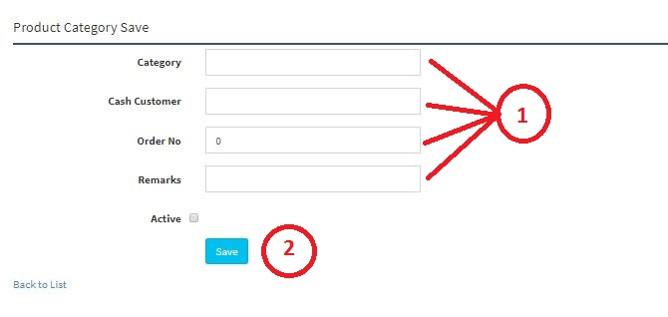**Step-02:** Enter any **“Date” or “Product”** in the search section and click “Enter” button to search any new RM Category.
* **Figure: 12 RM Category Entry Page**
* **Step-02:** Enter **‘Category’, ‘Cash Customer’, ‘Order No’, ‘Remarks’ (If Any)** and click “Save” button to save any new RM Category.

## **2.6 RM Sub Category**

**Figure: 13 RM Sub Category**

The following figure (Fig-03) shows options for RM Sub Category.

* **Step-01:** Click on the **RM Sub Category** section under **Settings (Feed) Menu** option. The following figure (Fig-03) shows the **Product of Feed** page.
* **Step-02:** Enter any **“Category”, ‘Sub Category’ or “Base Commission”** in the search section and click “Enter” button to search any products Sale price.
* Step-03:

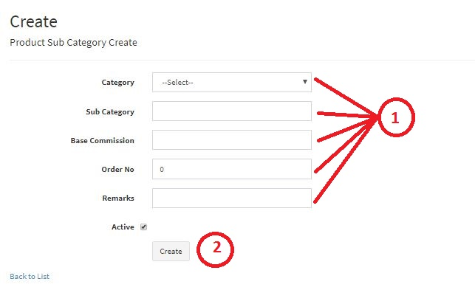

* **Figure: 14 RM Sub Category Entry Page**
* **Step-02:** Enter **‘Category’, ‘Sub Category’, ‘Base Commission’, ‘Order No’, ‘Remarks’ (If Any)** and click “Create” button to save any new Product Sub Categor.

## **2.7 Raw Material**

**Figure: 15 Raw Material**

The following figure (Fig-03) shows options for RM Category.

* **Step-01:** Click on the **Raw Material** section under **Settings (Feed) Menu** option. The following figure (Fig-03) shows the **Product of Feed** page.
* 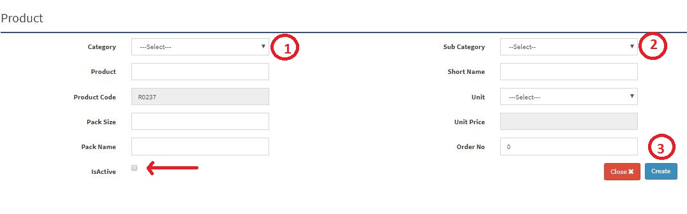**Step-02:** Enter any **“Category”, “Sub Category”, “Product”, “Product Code” or “Short Name”** in the search section and click “Enter” button to search any Raw Materials.
* **Figure: 16 Raw Material Entry Page**
* **Step-02:** Enter **‘Category’, ‘Sub Category’, ‘Product’, ‘Short Name’, ‘Pack Size’, ‘Pack Name’, ‘Order Name’** , must be click on Active button and click “Submit” button to save any new Raw Material.

## **2.8 Feed Formula**

**Figure: 17 Feed Formula**

The following figure (Fig-03) shows options for RM Category.

* **Step-01:** Click on the **Feed Formula** section under **Settings (Feed) Menu** option. The following figure (Fig-03) shows the **Product of Feed** page.
* 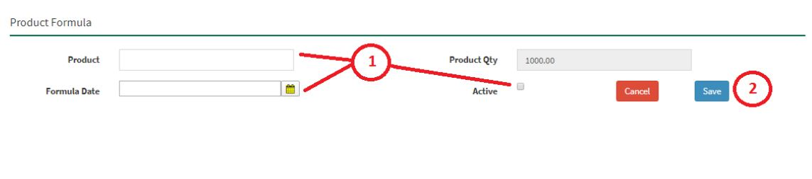**Step-02:** Enter any **“Formula Date” or “Product”** in the search section and click “Enter” button to search any Products Feed Formula.

**Figure: 18 Feed Formula Entry Page**

* **Step-02:** Enter **‘Product’, ‘Formula Date’, Click on Active Button** then click on “Submit” button to save any new Feed Formula.

## **2.9 District**

**Figure: 19 District**

The following figure (Fig-03) shows options for District.

* **Step-01:** Click on the **District** section under **Settings (Feed) Menu** option. The following figure (Fig-03) shows the **Product of Feed** page.
* **Step-02:** Enter any **“District” or “District Code”** in the search section and click “Enter” button to search any products Sale price.

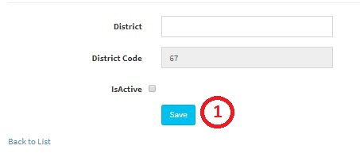

**Figure: 20 District Entry Page**

* **Step-02:** Enter **‘District’, ‘Check Active Button’** and click on “Save” button to save any new District.

## **2.10 Upazila**

**Figure: 21 Upazila**

The following figure (Fig-03) shows options for RM Category.

* **Step-01:** Click on the **Product Sale Price** section under **Settings (Feed) Menu** option. The following figure (Fig-03) shows the **Product of Feed** page.
* **Step-02:** Enter any **“Date” or “Product”** in the search section and click “Enter” button to search any products Sale price.

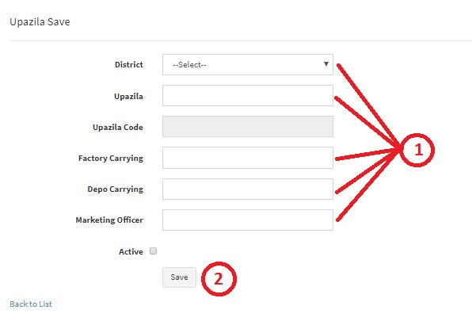

**Figure: 22 Upazila Entry Page**

* **Step-02:** Enter **‘Product’, ‘Price Date’, ‘Unit Price’, ‘Sale Commission’** and click “Submit” button to save any new Product Sale Price.

## **2.11 Assign Area**

**Figure: 23 Area Assign to Marketing Officer**

The following figure (Fig-03) shows options for RM Category.

* **Step-01:** Click on the **Product Sale Price** section under **Settings (Feed) Menu** option. The following figure (Fig-03) shows the **Product of Feed** page.
* **Step-02:** Enter any **“Date” or “Product”** in the search section and click “Enter” button to search any products Sale price.

## **2.12 Customers**

**Figure: 24 Customers**

The following figure (Fig-03) shows options for RM Category.

* **Step-01:** Click on the **Product Sale Price** section under **Settings (Feed) Menu** option. The following figure (Fig-03) shows the **Product of Feed** page.
* **Step-02:** Enter any **“Date” or “Product”** in the search section and click “Enter” button to search any products Sale price.

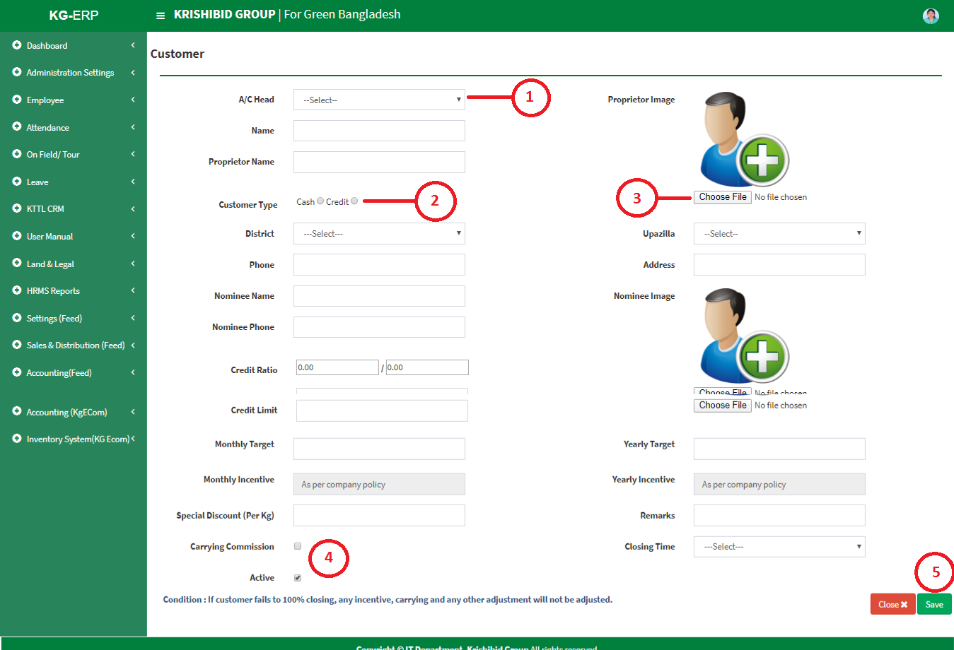

**Figure: 25 Customer Entry Page**

* **Step-02:** Enter **‘Product’, ‘Price Date’, ‘Unit Price’, ‘Sale Commission’** and click “Submit” button to save any new Product Sale Price.

## **2.13 Suppliers**

**Figure: 26 Suppliers**

The following figure (Fig-03) shows options for RM Category.

* **Step-01:** Click on the **Product Sale Price** section under **Settings (Feed) Menu** option. The following figure (Fig-03) shows the **Product of Feed** page.
* **Step-02:** Enter any **“Date” or “Product”** in the search section and click “Enter” button to search any products Sale price.

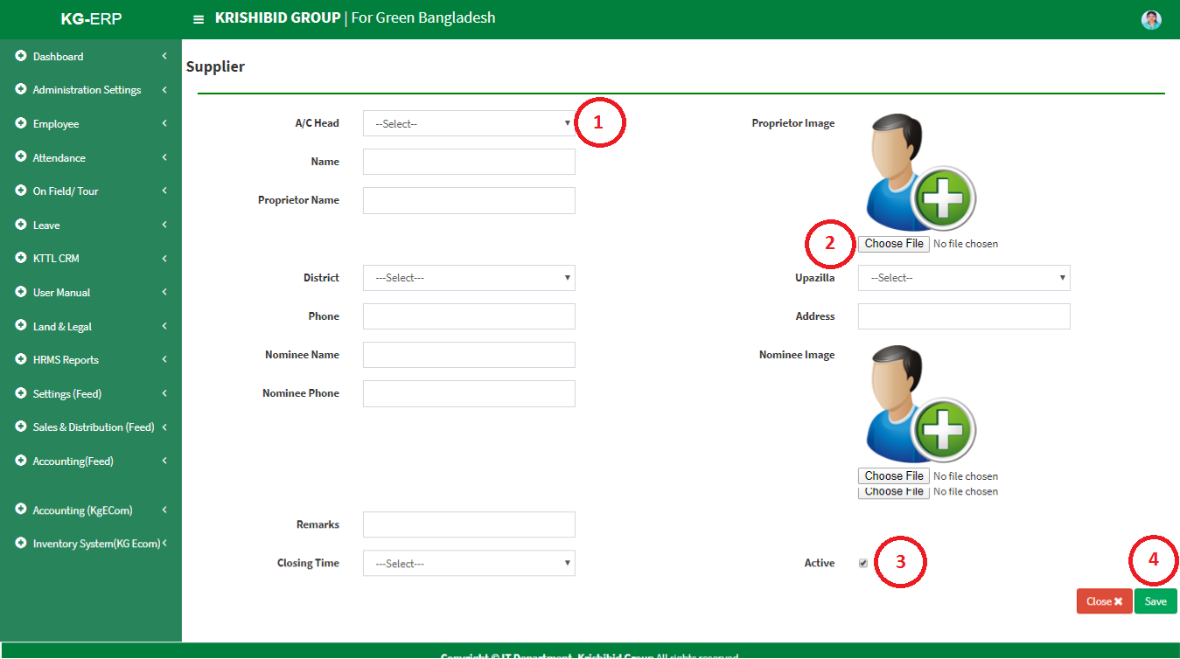

**Figure: 27 Suppliers Entry Page**

* **Step-02:** Enter **‘Product’, ‘Price Date’, ‘Unit Price’, ‘Sale Commission’** and click “Submit” button to save any new Product Sale Price.